Pedro Pietri, Ten Years After His Death
http://www.hispanicny.com/2014/03/pedro-pietri-ten-years-after-his-death.html

March 2, 2014 By Claudio Iván Remeseira
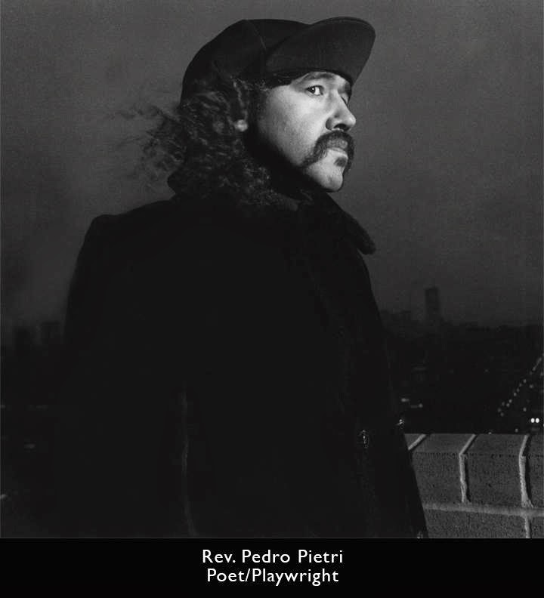
Ten years ago, The Reverend and First Saint of The Church of Our Mother of Tomatoes, a.k.a. Pedro Pietri, gave his last performance.
Diagnosed with an incurable stomach cancer, in January 2004 Pietri started a treatment at a holistic clinic in Mexico. On March 3, 2004, he died while he was flying back to New York City to take care of a bleeding ulcer. It was a fitting curtain call for an artist who made of the unexpected, shocking creative gesture a form of reflecting and subverting reality.
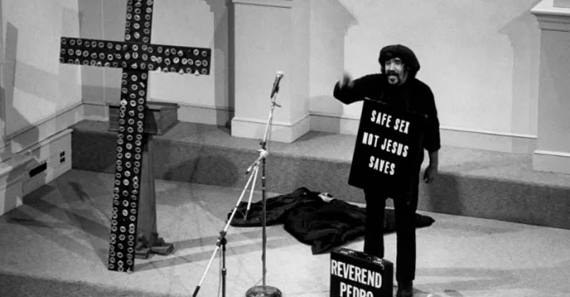
Born in Ponce, Puerto Rico, in 1947, Pedro Pietri moved to New York City three years later. His family was part of the big Puerto Rican migration that followed WWII, the first airborne mass migration in History. He grew up in the projects of Manhattanville, a few blocks away from where his contemporaries Oscar Hijuelos and George Carlin grew up.
Alongside fellow writers Miguel Algarín and Miguel Piñero, Pedro Pietri constitutes the Holy Trinity of the Nuyorican movement. As David Gonzalez put it in the obituary he wrote for New York Times:
“Mr. Pietri's poetry about the competing cultural tugs of New York and Puerto Rico was often playfully absurd. He was perhaps best known for "Puerto Rican Obituary," an epic poem published in 1973 that sketched the lives of five Puerto Ricans who came to the United States with dreams that remained unfulfilled. By turns angry, heartbreaking and hopeful, it was embraced by young Puerto Ricans, who were imbued with a sense of pride and nationalism.” The poem was first published in 1973 by Monthly Review Press in a collection of poetry with the same title.
The editors of the Monthly Review recall the history of this work:
“Puerto Rican Obituary” was first read in 1969 at a rally in support of the Young Lords Party, an anti-imperialist Latino youth group in New York. Like the Black Panther Party, the Young Lords were community activists, supporting demands for fair and affordable housing and decent health care, and they ran free breakfast programs for children. They linked their neighborhood militancy to a program that called for the end of U.S. imperial adventurism in Vietnam and elsewhere, third world liberation, an end to the oppression of the poor and people of color, and the building of a socialist society ... Pietri continued on as a radical activist and poet—he saw no distinction between these roles. Most notably he helped to found and sustain the Nuyorican Poets Cafe, an acclaimed center for oppositional arts and literature.

... After high school, he was drafted into the U.S. army, served in Vietnam, and returned to the United States a fierce opponent of that war and the system that spawned it. “I realised who the real enemy was, and it was not the Vietcong in their black pajamas, but the mercenaries who invaded their country” ... The power, insight, and message of “Puerto Rican Obituary” continue to resonate among activists and dreamers all over the world. As the New York Times put it recently “three decades ago, a poem ignited a movement.”
Pietri's work include Spanglish National Anthem and The Masses Are Asses. His papers are held at the Archives of the Puerto Rican Diaspora, CUNY's Center of Puerto Rican Studies, Hunter College.
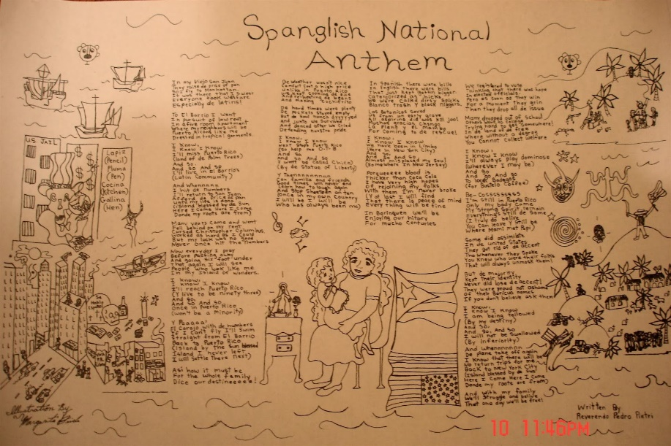
Photo: CUNY Student Projects - El Barrio

