Student Background Reading
The Young Lords
The Young Lords was a student activist group similar to the Black Panthers. Active in the1950s and 1960s in Chicago and New York, these young Puerto Rican Americans organized protests and demonstrations to bring public attention to a number of problems. They worked tirelessly on issues such as healthcare, women’s rights, and prisoners’ rights. They created a “13-Point Program” that called for things such as liberation for Puerto Rico, equality for women, and an end to racism. The Young Lords were able to set up free breakfasts for school children, community health tests, clothing drives, and many community events that showed their pride in Puerto Rican culture and history. The group was controversial, however, because they advocated armed self-defense and a socialist society.
One of the issues that the Young Lords focused on was education. he low college acceptance rates for Puerto Ricans and African Americans led to the 1969 sit-in at the south campus of the City University of New York. Students locked themselves in several buildings and forced the school to close down. They asked for an open admissions policy, Black and Puerto Rican studies programs, as well as Spanish language classes, for all education majors.
Community members responded by bringing food and blankets to the protesters. There were skirmishes with the police and after dozens of student activists were arrested, the takeover finally ended. The Young Lords were instrumental in establishing a more open college admissions policy, the creation of Puerto Rican studies programs, and the establishment of several student organizations.
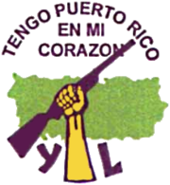

Pedro Pietri (1944-2004)

Pietri was born in Ponce, Puerto Rico and moved with his family to the Harlem neighborhood of New York City in 1947. A member of the Young Lords when the group was active, Pietri composed provocative poetry, plays, and art work, giving voice to many of the hardships Latinos faced. He died of stomach cancer in 2004.
His best known work is the poem "Puerto Rican Obituary.” In this poem published in 1973, Pietri recounts the experiences of many Puerto Ricans who migrate to New York in search of the American dream, only to be met with discrimination and suffering.
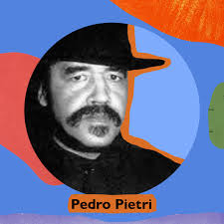
Puerto Rican Obituary (excerpt)
They worked
They were always on time
They were never late
They never spoke back
when they were insulted
They worked
They never took days off
that were not on the calendar
They never went on strike
without permission
They worked
ten days a week
and were only paid for five
They worked
They worked
They worked
and they died
They died broke
They died owing
They died never knowing
what the front entrance
of the first national city bank looks like

Excerpt from: Cruz, B.C. (2008). Triumphs and Struggles for Latino Civil Rights. Enslow Publishers
Pedro Pietri, “Puerto Rican Obituary,” Monthly Review 26(1), May 1974, 57-62.

