**University of South Florida**

**College of The Arts**

**and**

**Tampa International Airport   
NEWS RELEASE**

**September 17, 2019**

# Press Contact

# Kelly Figley: kfigley@tampaairport.com or (813) 801-6028

Mark Fredricks: fredricks@usf.edu or (813) 974-3503

# 

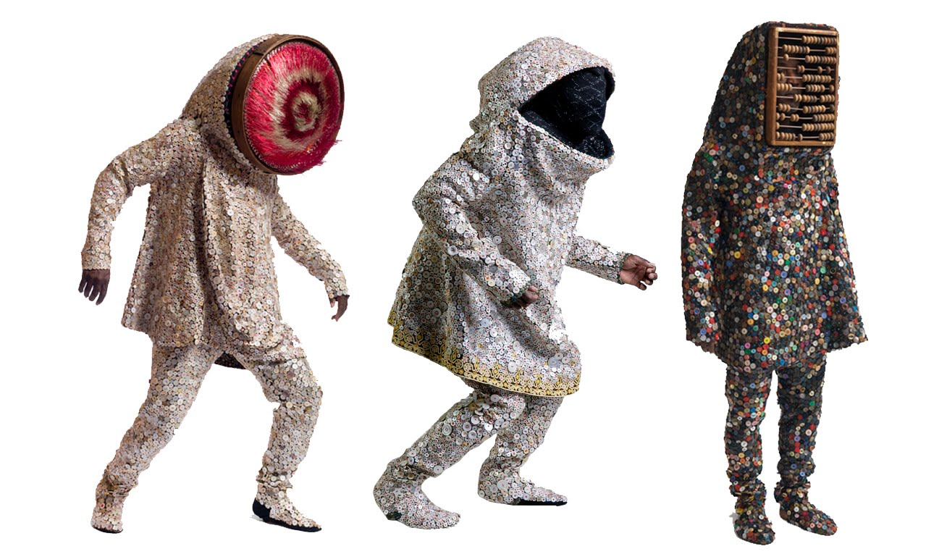

**Tampa International Airport and the University of South Florida partner to present a talk and workshop with acclaimed artist Nick Cave and his collaborator Bob Faust**

**(Tampa – September 17, 2019)** On **Tuesday, October 8 at 5:30pm**,Tampa International Airport and the University of South Florida College of The Arts are pleased to present ***Art, Performance, and Empowerment*, a free artist talk** with celebrated artist **Nick Cave**. The event begins at the Tampa International Airport in the third floor event space between Terminals E and F. Remarks from Joe Lopano, CEO of the Tampa International Airport and Steve Currall, USF System President, will precede Cave’s presentation. Following the talk, Cave and collaborator Bob Faust will lead attendees to their work *Palimpsest*, a 45-foot-wide and 70-foot-long hanging sculpture in the new Rental Car Center. The work is one of seven public art installations for Tampa International Airport’s expansion as part of Master Plan Phase 1.

On Wednesday, October 9 from 10:00am to 4:00pm Cave and Faust will be in Theatre 2 on the USF Tampa campus presenting ***Identity and the Art of Introduction***. Cave and Faust will lead a select group of multi-disciplinary USF students in this all-day workshop on the power of collaboration and the critical role that understanding each other, as people and artists, plays among participants. Interested artists, community members, and students are invited to drop in throughout the day to observe this workshop.

**Event Details**

Artists Talk: *Art, Performance, and Empowerment*

Date: Tuesday, October 8

Time: 5:30pm

Location: TPA Event Space, 3rd Level of Main Terminal, Tampa International Airport, 4100 George J Bean Pkwy, Tampa, FL 33607

FREE, but space is limited. RSVP to [TPAevents@tampaairport.com](mailto:TPAevents@tampaairport.com) to attend.

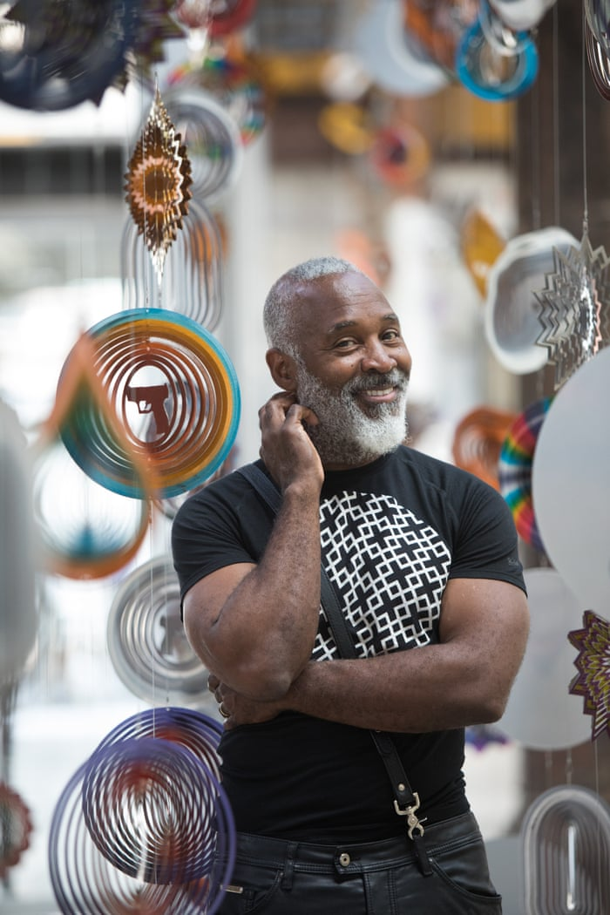Workshop: *Identity and the Art of Introduction*

Date: Wednesday, October 9

Time: 10:00am – 4:00pm

Location: USF Theatre 2 (THR), 3829 USF Holly Drive, Tampa, FL 33620

FREE, but viewing space is limited. RSVP to [irarsvp@usf.edu](mailto:irarsvp@usf.edu) to observe.

**About The Artists**

Chicago-based artist Nick Cave is an educator and messenger known for working between the visual and performing arts, using a wide range of mediums including sculpture, installation, video, sound, and performance. Cave and his long-time project and personal partner, Bob Faust, have developed a 20,000 square foot space in Old Irving Park to serve as an incubator for collaboration and to inspire young artists.

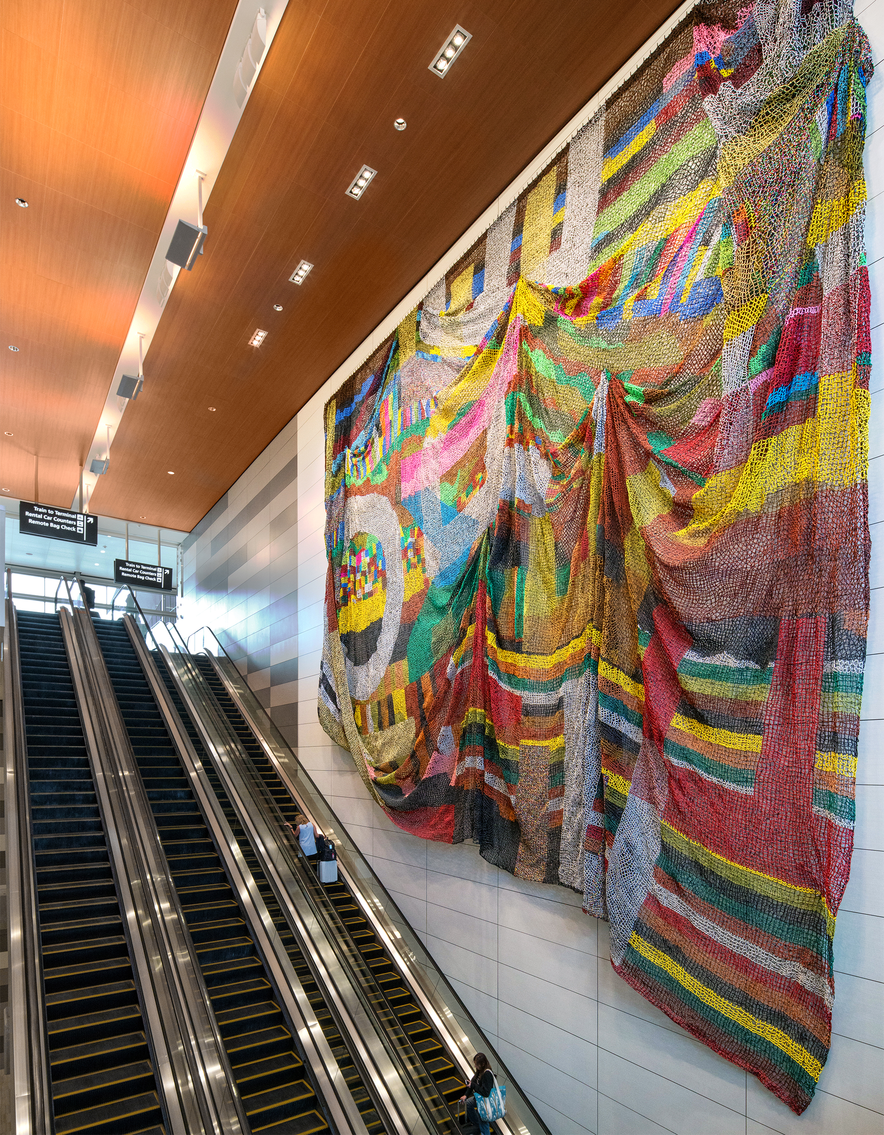

**Links to Press and Media about Nick Cave**

[Art 21: *Chicago*](https://art21.org/watch/art-in-the-twenty-first-century/s8/nick-cave-in-chicago-segment/) – Art 21 video feature on Nick Cave from their episode devoted to the city of Chicago, 9/16/16.

[Architectural Digest](https://www.architecturaldigest.com/story/nick-cave-interview) – *Why Artist Nick Cave is Commanding the Spotlight Globally*, Brook Mason, 6/26/18.

[New York Times](https://www.nytimes.com/2018/11/01/arts/design/nick-cave-chicago.html) – *Nick Cave Uses His Capital to Help Aspiring Creators*, Hilarie M. Sheets, 11/1/18.

Nick Cave and Bob Faust, Palimpsest, 2018

**About the Tampa International Airport**

Tampa International Airport is consistently ranked among the world’s favorite airports, serving 22-million passengers annually with nonstop routes to more than 90 destinations around the world, including Frankfurt, Zurich, Panama City, London, Cayman Islands, Havana and Amsterdam. In the past few years, Travel + Leisure Magazine, Conde Nast Traveler and J.D. Power have named TPA among the top three domestic airports, and TripAdvisor reviewers ranked it the No. 2 large U.S. airport and No. 4 in airport dining. Tampa International Airport is undergoing a three-phase historic expansion, having recently expanded its main terminal with a 1.4-mile people mover extending to a new rental car facility, and it is currently adding express curbsides, commercial development and other projects.

**About the USF College of The Arts**

The College of The Arts is the creative center of the University of South Florida’s Tampa campus. Dedicated to preparing students for careers in architecture, community design, art, art history, music, theatre, and dance, the College provides students with a hands-on learning environment where real-world exhibition, performance, and practice opportunities abound. Situated in a culturally rich metropolitan area, students and faculty participate in Arts research through interdisciplinary work, global explorations, and local community engagement in Tampa Bay. <[usf.edu/arts](https://www.usf.edu/arts/)>

**About the USF Institute for Research in Art**

The USF Institute for Research in Art (IRA) is the umbrella organization for the Contemporary Art Museum, Graphicstudio, Public Art program, and Art in Health. Part of the University of South Florida College of The Arts, the IRA is dedicated to an international artists’ residency program that brings to the University and Tampa Bay community today’s most accomplished and influential artists working in the international art arena. Exhibitions, collection development, publication of limited edition graphics and sculpture multiples, commissioned public art works, interdisciplinary arts research, lectures, symposia, workshops and special events are designed to foster awareness about the role of contemporary artists in shaping our culture and society. Participating artists represent the full and diverse spectrum of contemporary art practice including, but not limited to, painting, sculpture, photography, electronic media, and performance. <[ira.usf.edu](http://ira.usf.edu/)>

###